WHAT

Text 1

I. summarize each paragraph in one sentence or phrase

|  |  |
| --- | --- |
| Text | Summary |
| Facebook recently reminded me that I’ve been on the social network for 15 years. I normally pay little attention to those anniversary notices, but this time I paused to think about how much had changed in the decade and a half since Facebook was founded – and the roller coaster of feelings I’ve had toward the tech platform over that time. Excitement about its promise, pride in its millennial origins, gratitude for the ease of staying in touch with old friends, equal parts worry and admiration over its “move fast and break things” philosophy, frustration at its approach to privacy, worry about its addictiveness, concern by its manipulative use by Russia, the list goes on. It’s been a wild 15 years. |  |
| Around the same time as I got that notification, I was reading Roger McNamee’s well-written new book, Zucked: Waking up to the Facebook Catastrophe. McNamee was an early investor in Facebook and an advisor to Mark Zuckerberg and Sheryl Sandberg. But over time – and particularly in the weeks before the 2016 election – he grew concerned that the platform designed to bring the world together was being used to cause confusion and division. McNamee reached out to the company and was unsatisfied with the response. So he dug deeper and deeper into problems with the social network – and eventually went public with his criticism. Zucked is not only the personal odyssey of a former Facebook investor but an insightful case study in the range of challenges that the platform – and all tech platforms – raise for society. |  |
| McNamee offers many critiques of Facebook, but his central argument is that Facebook is a threat to the economy, public health, and democracy. The economic critique rests on the problems of monopoly capitalism, including, for example, Facebook’s ability to buy up potential rivals like Instagram and WhatsApp before they might have had a chance to challenge its dominance. The democracy critique is in the news almost daily. Democracy cannot survive without debate and deliberation based on shared truths. But NewsFeed pushes us into “filter bubbles,” so we increasingly are walled off from different opinions. McNamee argues that this has had an impact not just in America, but all around the world. |  |
| The public health critique often gets less attention. McNamee describes various tactics for how tech companies get people to use their products more, even to the point of addiction. For example, NewsFeed relies on the “bottomless bowl” – an unending list of posts that keeps people in the site for longer. Notifications distract from the task at hand and attract users back into the app. McNamee argues that these and other design strategies have a profound effect on human happiness and fulfillment and that we are worse off because of how they are configured. |  |

II. What is the issue?

III. Mind-map

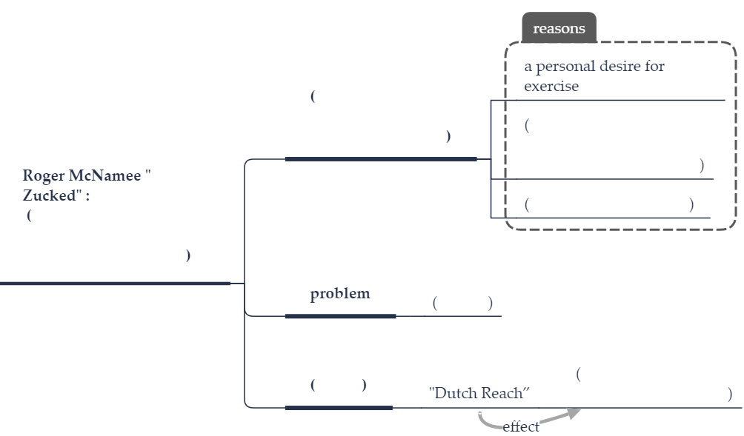

Text 2

I. summarize each paragraph in one sentence or phrase

|  |  |
| --- | --- |
| Text | Summary |
| James Reed, chairman of recruitment firm Reed, recalls, as a child, queuing with his mother at the bank and being so bored, until ATMs made it possible to access cash at any time – day or night – without waiting around. | - |
| “Similarly, when it came to job hunting, I knew there was a quicker, more effective way for people looking for their next role,” he says. “I could see immediately that the internet was the perfect tool for people to look for jobs in their own time, whenever and wherever they wanted, and so reed.co.uk was born.” In 1995, reed.co.uk became the first recruitment website offered by a recruitment agency in the UK, and within two years the online portal became a prime source of applicants for the business. Initially built to find and hire talent for the recruitment agency itself, in 2007 reed.co.uk became a strong business in its own right. |  |
| Online technology has revolutionised the way that many large traditional companies such as Reed operate. |  |
| “It has enabled us to greatly increase our reach and to serve much larger audiences,” says Reed. “It has also accelerated the recruitment process, with the net result that we have been able to source many more candidates for our clients much quicker than we’d been able to do previously.” |  |
| As chief executive of AXELOS, which creates and accredits guidance and qualifications for IT professionals, Mark Basham has witnessed much of the digital disruption that is reshaping how business processes and practices have changed in recent years. |  |
| “Technologies such as the cloud and the evolution of software as a service (SaaS) into everything as a service (XaaS), and the opportunities they provide for fast scaling, have had the biggest impact on business, while smartphone and mobile app technologies have transformed customer interactions, raising speed and expectations of service to new levels,” he says. “This has meant massive change for companies.” |  |
| And this need for businesses to keep pace with new technologies doesn’t show any sign of letting up. “Our data scientists are using machine learning to increase the accuracy of relevant job search results,” adds Reed. “We are also working on developing artificial intelligence solutions in CV screening to help eliminate unconscious bias, so that all CVs will be evaluated consistently.” |  |
| It’s difficult to identify an industry whose business operations have not been profoundly altered by new technologies. With a manufacturing history spanning more than 100 years, Formica Group Europe has seen huge technological changes and embraced many of them. Last year, the company launched a £40m investment plan that will include the implementation of the latest technology to create a manufacturing plant in the UK. |  |

II. What is the issue?

III. Mind-map

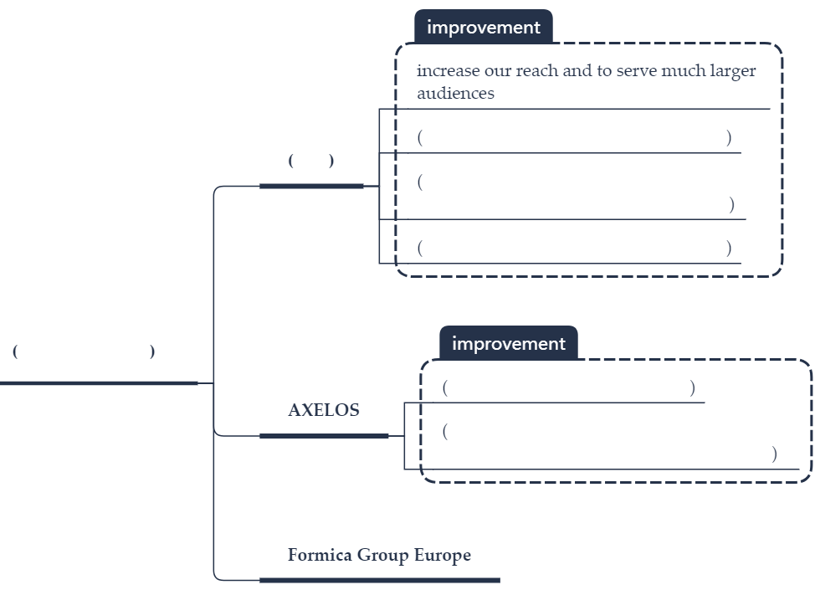

Text 3

I. summarize each paragraph in one sentence or phrase

|  |  |
| --- | --- |
| Text | Summary |
| As a chest surgeon who has been operating on lungs since 1988, I am pained to say that it is time to call India’s deadly pollution crisis a public health emergency. |  |
| Over the years, I have witnessed a change in the color of patients’ lungs from pink to black. It is a rarity for me to see a normal pink lung in any adult patient today. In essence, there are no nonsmokers in India, given our badly polluted air. Newborns in many of our cities become “smokers” from their very first breath. |
| Business leaders and government officials gathering here for the World Sustainable Development Summit this week must face this reality: India’s development is anything but sustainable. An unhealthy population cannot build a strong nation. The government must declare an emergency and swiftly enact transformational change in policies regarding energy and transportation, the two main contributors to air pollution. |  |
| The science demands it. A recent study by the Lung Care Foundation on the air in New Delhi and an adjoining city revealed shockingly high levels of manganese, lead, nickel, barium, silicon and iron. And while New Delhi has attracted the most attention, the problem of air pollution is pan-India, with hardly any city in the country coming anywhere close to World Health Organization standards, except on a few days of continuous rain. |  |
| Breathing such highly polluted air has deadly health consequences. Toxins in polluted air (particulate matter, gases and other chemicals) are taken in through the lungs, and then many pass into the lung membrane, enter blood circulation and eventually reach every organ in the body. While lungs bear the brunt of the attack, blood vessels, the brain, the heart and other organs are also badly affected. |  |
| Such exposure can lead to chronic diseases. Breathing toxic air is directly responsible for the rise of asthma among Indian schoolchildren to as high as 25 percent. Well more than a million deaths in India in 2017 are reportedly due to air pollution. |  |
| Even more disturbing is the change in lung cancer patterns I’ve witnessed over the past three decades: an overall increase, a higher occurrence in younger people and a high incidence among nonsmokers. I’ve seen young people who’ve never smoked come in with stage four lung cancer — robbed of their lives because of the inaction of their elders. |  |
| A major challenge is the lack of awareness. Indians know that pollution is bad for them and their children, but many do not understand the extent to which the damage carries in the body, with brutal effects. This lack of awareness leads to apathy. Thus, doctors must educate patients and not just after they’ve been diagnosed with a pollution-related disease. |  |

II. What is the issue?

III. Mind-map

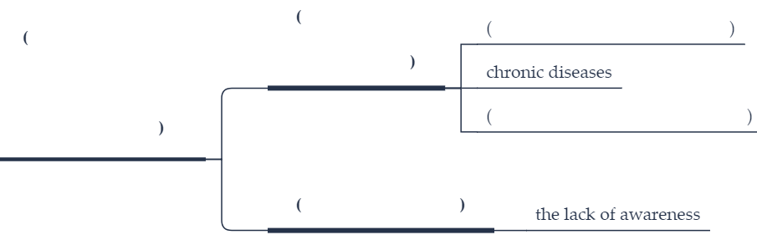

Text 4

I. summarize each paragraph in one sentence or phrase

|  |  |
| --- | --- |
| Text | Summary |
| In its latest survey of 180 countries by levels of corruption, Transparency International tried something different. For the first time, the global watchdog group measured links between public-sector corruption and each country’s basic freedoms, rule of law, and democracy. The researchers need not look too far to find current negative examples. |  |
| In recent weeks, the world has witnessed mass protests in two of the most-corrupt countries, Sudan and Venezuela, which are also among the most nondemocratic. Each country could be on the brink of regime change. In each country, demonstrators demand the kind of honesty and accountability in governance that they see in healthy democracies. |  |
| In Sudan, which is Africa’s third-biggest country, the regime chose to balance its budget by raising bread prices rather than by reducing corruption. The move brought people into the streets in unprecedented unity across ethnic divisions. In Venezuela, the robbing of oil wealth by the political elite and military brass finally united the opposition in the elected legislature and led to popular demands for an end to a culture of exemption. |
| The report found full democracies scored an average of 75 out of 100 on the corruption index. Flawed democracies averaged 49 while autocratic regimes averaged30. Yet the real value in the survey lies in a list of countries that have reduced corruption by improving their democracies. That link was clear. |  |
| In the past seven years, 20 countries have made such progress. None are perfect. Even Denmark, a strong democracy that is also ranked as the least corrupt, saw its largest bank caught in a huge money-laundering scheme last year. Yet nations on the list can provide lessons for the majority of countries that remain below average in the TI rankings. |  |
| Anti-corruption reforms in Senegal and Ivory Coast, for example, are a result of a new “political will ... demonstrated by their respective leaders.” In Argentina, Ecuador, and El Salvador, reform is led by better investigations in corruption cases against high-profile individuals, including some former presidents. Estonia’s progress is a result of radical reform of the courts and public administration, a relatively clean privatization of state enterprises, and digital transparency in government dealings. |  |
| Among its own recommendations, TI researchers cite the need for a broad social consensus in favor of integrity in public institutions. “Engagement of citizens in oversight of government decisions and spending, particularly at the local level, not only crowdsources accountability but promises to re-invigorate the democratic process,” the report states. |  |
| So while watching protests like those in Sudan or Venezuela, it is helpful to view them as simply an outbreak of citizen engagement in favor of integrity. Many other countries have been there, done that. | - |

II. What is the issue?

III. Mind-map

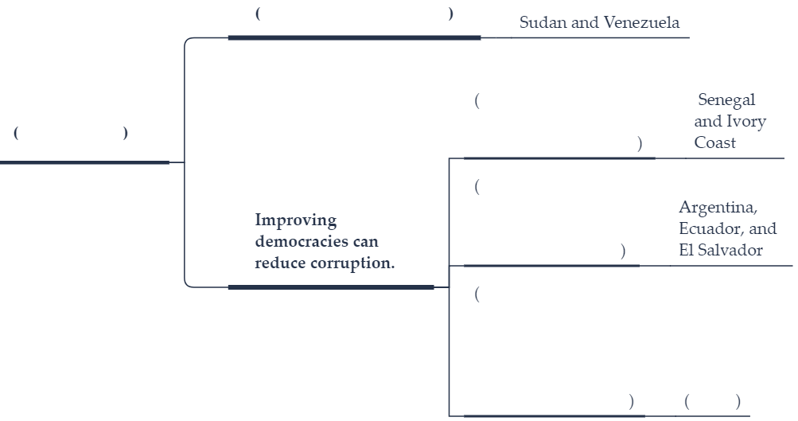

Text 5

I. summarize each paragraph in one sentence or phrase

|  |  |
| --- | --- |
| Text | Summary |
| This summer, the government of Ontario begins a social experiment that will put the character of some 4,000 people to the test. The Canadian province will give as much as $16,989 (Canadian; US$12,616) a year to selected low-income individuals, whether or not they are working or on government assistance. Over three years, the recipients will be tracked to see if they have wasted the free money or, as Ontario Premier Kathleen Wynne hopes, they “get ahead and stay ahead.” |  |
| This is one of the boldest attempts yet to move toward a much bigger idea called universal basic income, or the government providing a guaranteed financial floor to everyone regardless of their personal wealth. | - |
| Much of the advocacy for the idea has come from high-tech celebrities. Last week, for example, Facebook founder and chief executive officer Mark Zuckerberg told the graduating class at Harvard University, “We should explore ideas like universal basic income to make sure that everyone has a cushion to try new ideas.” |  |
| Last June, Switzerland considered a full-fledged plan of about $2,500 a month for everyone– not only those who are jobless or on state aid. Yet in a public vote, nearly 80 percent of Swiss voters rejected it. By one estimate, the plan would have cost 30 percent of gross domestic product. Yet more important, many worried about the potential effects on people’s work ethic and self-reliance. |  |
| The question of character keeps rising in the debate over universal basic income. If given minimal financial security, would people still be willing to find a greater purpose in work or other activities that contribute to society? Or would they become inward-looking and lazy? |  |
| In a recent TED Talk, Rutger Bregman, a Dutch historian and an advocate of basic income, argued that such plans would curb many bad habits of the poor. “Poverty is not a lack of character. Poverty is a lack of cash,” he said. He quotes economist Joseph Hanlon: “You can’t pull yourself up by your bootstraps if you have no boots.” |  |
| Others are more nuanced. In a new book, “Basic Income: A Radical Proposal for a Free Society and a Sane Economy,” Belgian academics Philippe Van Parijs and Yannick Vanderborght explore all sides of the arguments but contend that any basic income plan must be universal. Otherwise, giving money only to the poor or jobless will turn them “into a class of permanent welfare candidates.” And to avoid a backlash against the higher taxes needed to pay for a basic income, they suggest each individual in the United States receive $1,163 per month. That is about a quarter of the average per capita income and, by their estimate, would still provide an incentive to find work. |  |
| As different governments test out the feasibility of a guaranteed basic income, the question must be answered: Will such schemes reduce character or enhance it? |  |

II. What is the issue?

III. Mind-map

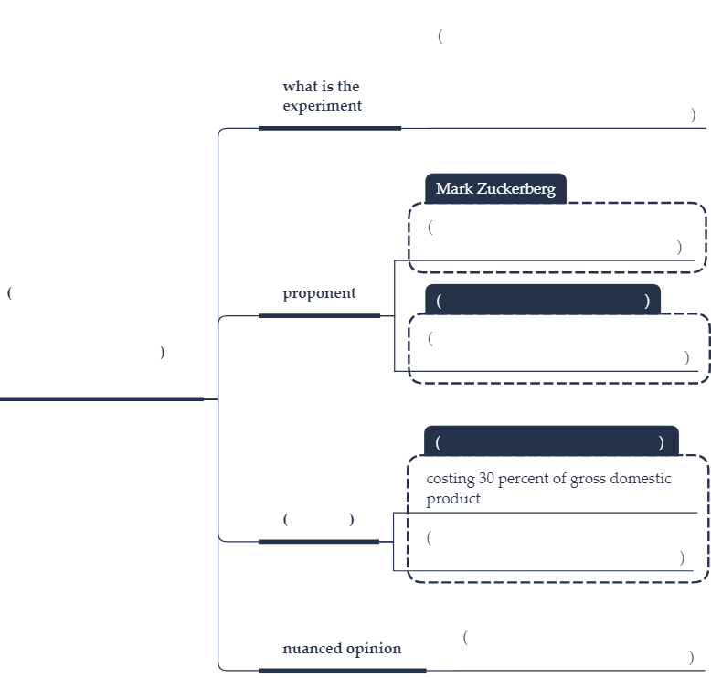

Text 6

I. summarize each paragraph in one sentence or phrase

|  |  |
| --- | --- |
| Text | Summary |
| The latest World Health Organization report on measles epidemics shows that cases jumped by 50% last year. In one of the poorest and least connected countries in the world, Madagascar, nearly a thousand children are reported to have died after a measles outbreak in the countryside. An emergency programme of vaccination seems to have contained that epidemic for the moment but it is a reminder of how devastating the disease can be against unprepared populations. In the rich world, meanwhile, previously prepared populations are having their defences dismantled from the inside. |  |
| The discovery of advertisement campaigns against vaccination on social media is unusually worrying. It shows how the widespread availability of sophisticated advertising techniques is going to give considerable power to people who previously had no way of getting their message across to large numbers. In the most recent US campaigns against vaccination, 147 different advertisements have been used and some viewed more than 5-million times. |  |
| Social Media must take some responsibility for the consequences of their profit-seeking behaviors. Neither company should be profiting from an activity so harmful to public health as anti-vaccination promotion. Advertising against vaccination might be considered even more anti-social than tobacco smoking. The teenager who smokes puts their own body at risk, whereas the parent who refuses a child vaccination is unlikely to harm their own health at all: only that of their offspring. If this were just a decision to allow their own children to run a small risk, it might be defended. But it is not. Because of the way that community immunity works, such parents are threatening other people’s children too, some of whom cannot for medical reasons be vaccinated. |  |
| In some western countries threatened by campaigns against vaccination there are rules in place to stop unvaccinated children from attending school. This protects communities and sends a powerful signal to the wider world, but it is a desperate step. It risks punishing children twice for their parents’ faults. |  |
| If parents trusted the state, the medical profession, or the guardian of the media, this problem would not arise. The roots of the protests against vaccination lie for a large part in the unexpressed but powerful sense that modern life is dehumanising, and that powerful forces are collaborating to turn us into obedient robots and to force out our humanity. When power is no longer trusted, it does not matter that it telling the truth. Yet the distrust of anti-vaccination parents is a threat to everyone’s children and not just their own. |  |
| One step is obviously a campaign of public education by figures who are trusted by the target audience in the way that their friends on social media are. But not everything can be left to governments and large companies. Parents who care about their own children’s health must be prepared to take the argument to the playgrounds and on to social media as well. |  |

II. What is the issue?

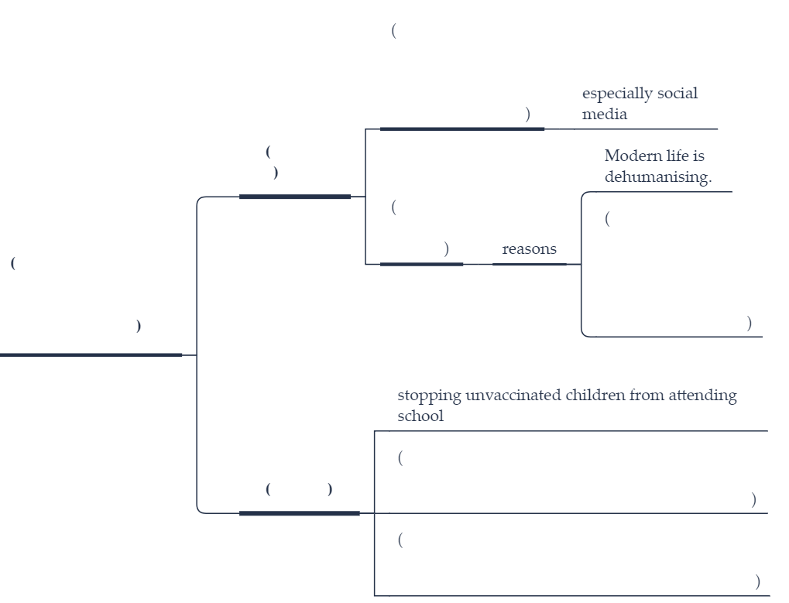III. Mind-map